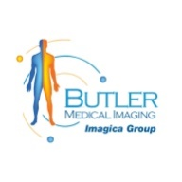Detecting Blocked Arteries with Cardiac CT Scans: Book Your Scan at Butler Medical Imaging Today!

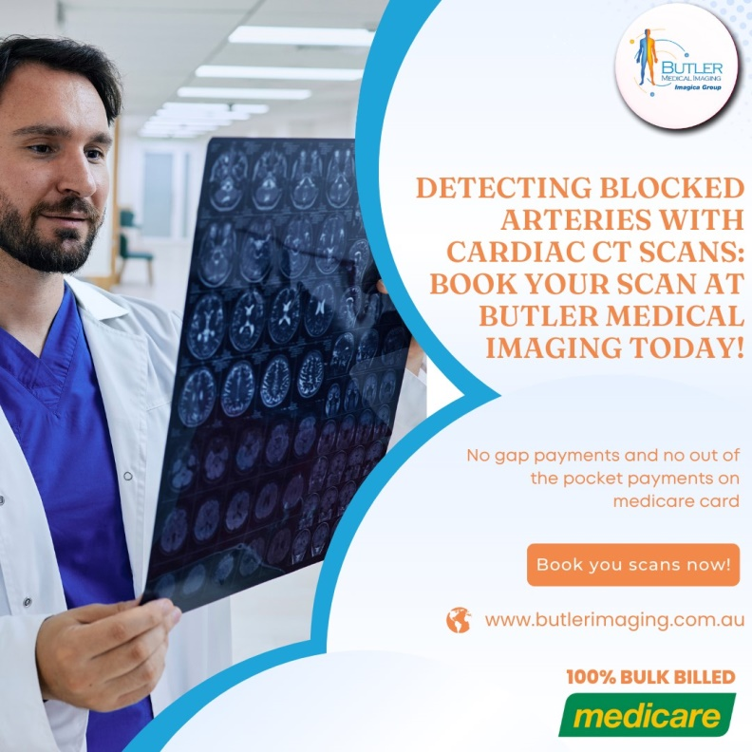Heart disease remains one of the leading causes of mortality worldwide, with blocked arteries (or coronary artery disease) being a primary contributor. Blocked arteries prevent sufficient blood flow to the heart, increasing the risk of heart attack, chest pain, and other serious conditions. Early diagnosis is crucial, and one of the most effective diagnostic tools available today is the [cardiac CT scan.](https://butlerimaging.com.au/ct-cardiac/) At Butler Medical Imaging, we are proud to offer high-quality cardiac CT services, providing accurate, non-invasive insights into heart health.

## Understanding Cardiac CT Scans

A cardiac CT scan, also known as coronary CT angiography (CTA), uses advanced X-ray technology to capture detailed images of the heart and its blood vessels. This scan can reveal any blockages or narrowing in the coronary arteries, which are the vessels responsible for supplying oxygen-rich blood to the heart muscle. Unlike traditional angiograms, which require inserting a catheter into a blood vessel, a cardiac CT scan is non-invasive, making it a preferred choice for many patients.

## How Does a Cardiac CT Scan Work?

The process of a [cardiac CT scan](https://butlerimaging.com.au/ct-cardiac/) is quick, comfortable, and highly effective. Here’s how it works:

1. Preparation: Before the scan, you may be given medication to slow down your heart rate, as a slower heart rate can produce clearer images. Some patients may also receive a contrast dye injected into their bloodstream to enhance the visibility of blood vessels in the images.
2. Scanning Process: During the scan, you lie on a table that slides into the CT scanner. As the machine rotates around you, it takes multiple X-ray images from different angles. These images are then compiled by a computer to create cross-sectional, 3D views of the heart and arteries.
3. Duration: The scan itself typically takes less than 15 minutes, and the entire process may take around 30 minutes, including preparation and waiting time.
4. Post-Scan: Since the procedure is non-invasive, there is minimal to no downtime after the scan. The results are interpreted by a radiologist and shared with your doctor, who will discuss the findings and potential treatment options with you.

## Can a Cardiac CT Scan Detect Blocked Arteries?

Yes, a cardiac CT scan is an excellent tool for detecting blocked or narrowed arteries. By providing high-resolution, 3D images of the coronary arteries, the scan can identify plaques (fatty deposits) that may be causing blockages or reducing blood flow. Here’s how a [cardiac CT scan](https://butlerimaging.com.au/ct-cardiac/) helps in diagnosing blocked arteries:

**Identifying Plaque:** Plaque buildup in the coronary arteries is the main cause of blockages. Cardiac CT scans can detect both hard and soft plaques. Hard plaque contains calcium deposits, which appear brighter in the images, while soft plaque consists of fatty material. Both types of plaque contribute to blockages, but soft plaque is particularly dangerous because it can rupture and lead to a blood clot, which may cause a heart attack.

**Measuring Severity:** In addition to identifying plaque, a cardiac CT scan helps measure the severity of artery narrowing. This allows physicians to assess the degree of blockage and determine if intervention, such as medication or surgery, is needed. The scan can also provide a calcium score, indicating the amount of calcium in the coronary arteries. Higher scores suggest an increased risk of heart disease.

**Detecting High-Risk Conditions:** In some cases, the scan can reveal high-risk plaques that are more likely to rupture and cause severe cardiac events. Detecting these dangerous plaques early allows for proactive intervention, reducing the likelihood of complications.

**Monitoring Disease Progression:** For patients already diagnosed with heart disease, cardiac CT scans can monitor changes in arterial plaque over time. This helps doctors evaluate the effectiveness of treatments and make necessary adjustments.

## Benefits of a Cardiac CT Scan for Detecting Blocked Arteries

Cardiac CT scans offer several advantages in diagnosing blocked arteries:

**Non-Invasive and Comfortable:** Unlike traditional angiography, [cardiac CT scans](https://butlerimaging.com.au/ct-cardiac/) are non-invasive, eliminating the need for catheter insertion. This means less discomfort and a shorter recovery time for patients.

**Quick and Convenient:** The scanning process is brief, and the advanced imaging technology produces results within minutes. This makes cardiac CT a convenient choice for patients who need timely assessments.

**High Accuracy:** Cardiac CT scans are highly accurate in detecting plaque and artery narrowing, allowing for early and precise diagnosis.

**Guiding Treatment Decisions:** By providing detailed images, cardiac CT scans aid in creating tailored treatment plans, whether that involves lifestyle changes, medications, or surgical intervention.

**Why Choose Butler Medical Imaging?**

We are local and a privately-owned medical clinics that offers the highest quality medical and Imaging Services in the [Butler Medical Imaging](https://butlerimaging.com.au/appointment/) region. We are the leaders in Bulk Billing with the real benefit of no ‘Out of Pocket’ expenses for you.

**Your Next Step**

Please ensure that you have your Medicare card and referral with you and pop into our location for your consultation. If you have any questions at all, please feel free to contact us at [+61 8 9544 3999](https://butlerimaging.com.au/appointment/) as we are here to help.